SARTHAK KESARWANI

1NT19IS141

**Hybrid Application Development**

Single child and multi child

Main.dart

import 'package:flutter/material.dart';

void main() { runApp(const MaterialApp(

home: RowApp(),

));

}

class RowApp extends StatelessWidget { const RowApp({Key? key}) : super(key: key);

@override

Widget build(BuildContext context) { return Scaffold(

body: Row(

mainAxisAlignment: MainAxisAlignment.spaceEvenly, crossAxisAlignment: CrossAxisAlignment.start, children: [

Container( height: 100,

width: 100,

color: Colors.*blueAccent*, child: Center(

child: Text("first child"

),

),

),

Container( height: 100,

width: 100,

color: Colors.*redAccent*, child: Center(

child: Text("second child"

),

),

),

Container( height: 100,

width: 100,

color: Colors.*yellowAccent*, child: Center(

child: Text("third child"),

),

)

],

),

);

}

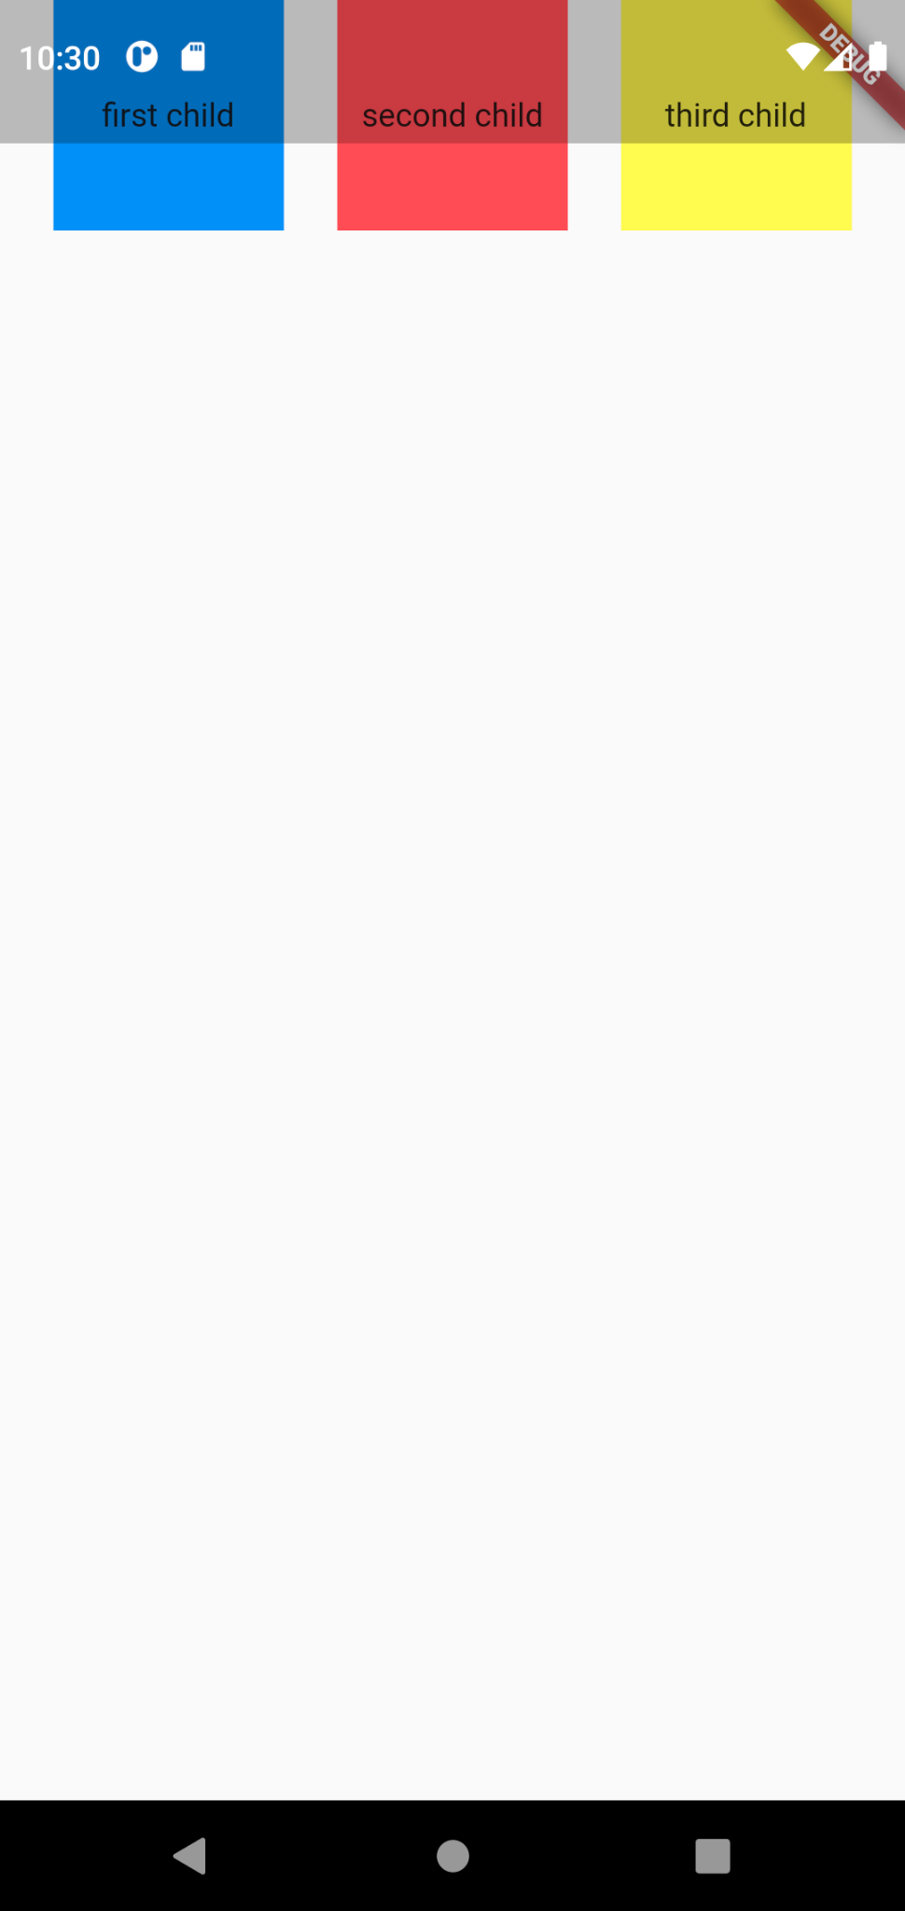}

2)

import 'package:flutter/material.dart';

void main() { runApp(const MaterialApp(

home: RowApp(),

));

}

class RowApp extends StatelessWidget { const RowApp({Key? key}) : super(key: key);

@override

Widget build(BuildContext context) { return Scaffold(

body: Column(

mainAxisAlignment: MainAxisAlignment.spaceEvenly, crossAxisAlignment: CrossAxisAlignment.start, children: [

Container( height: 100,

width: 100,

color: Colors.*blueAccent*, child: Center(

child: Text("first child"

),

),

),

Container( height: 100,

width: 100,

color: Colors.*redAccent*, child: Center(

child: Text("second child"

),

),

),

Container( height: 100,

width: 100,

color: Colors.*yellowAccent*, child: Center(

child: Text("third child"),

),

)

],

),

);

}

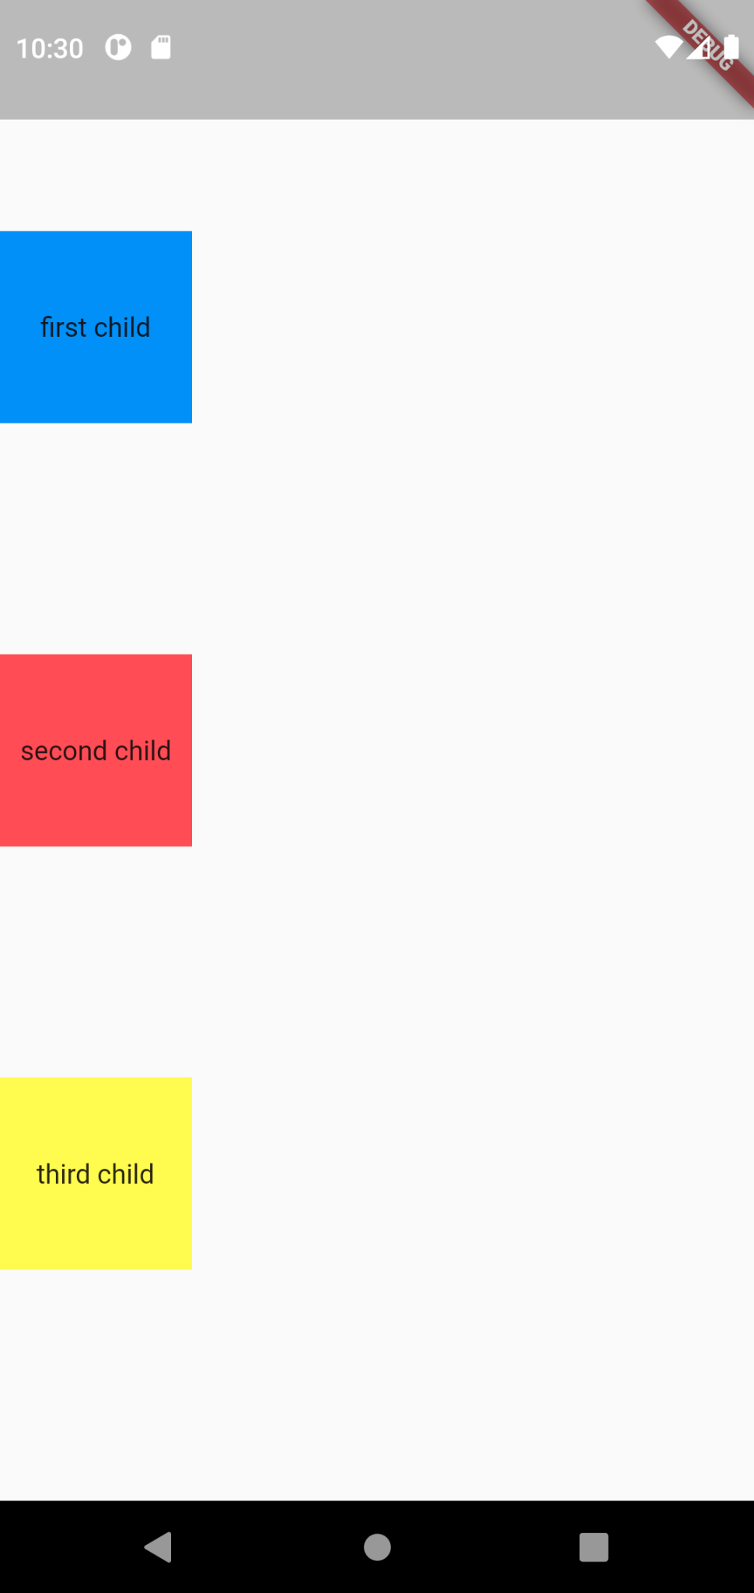}

import 'package:flutter/material.dart';

void main() { runApp(const MaterialApp(

home: RowApp(),

));

}

class RowApp extends StatelessWidget { const RowApp({Key? key}) : super(key: key);

@override

Widget build(BuildContext context) { return Scaffold(

body: Column(

mainAxisAlignment: MainAxisAlignment.spaceEvenly, crossAxisAlignment: CrossAxisAlignment.start, children: [

Container( height: 100,

width: 100,

color: Colors.*blueAccent*, child: Center(

child: Text("first child"

),

),

),

*//Padding(padding: EdgeInsets.fromLTRB(0, 0, 0, 0)),*

Container( height: 100,

width: 100,

margin: EdgeInsets.all(150), color: Colors.*redAccent*, child: Center(

child: Text("second child"

),

),

),

Container( height: 100,

width: 100,

color: Colors.*yellowAccent*, child: Center(

child: Text("third child"),

),

)

],

),

);

}

}

